WaterKleen™ Bidet
User Manual

Congratulations on your purchase of a WaterKleen™ Bidet. You have taken a good step to ultimate hygiene and comfort.
Using a bidet is very simple. Instead of using toilet paper on your hand to wipe at the end of your toilet session, you will be turning a nob on your control counsel to turn on a flow of soothing temperature controlled water stream.
It is not like a shower, it is like a stream of water out of the tap. The stream is directed up at the correct angle to gently wash away all fecal or urine matter. Once you have washed, tap dry with a piece of toilet paper.
You can also use the bidet to provide relief to the sensitive perineum area. Use of bidet instead of toilet paper is highly recommended for a number of conditions. Visit our website www.kleenbottom.com to learn more.
- Reduce bacterial vaginosis and vaginal itch in women
- Removes vaginal odor
- Prompts relief from chronic constipation
- Reduce Urinary Tract Infections (UTI)
- Reduce hemorrhoid irritation
- Provide relief from Prostatitis

The WaterKleen™ has a self-cleaning feature. Use this feature once a month.
quality tested
We test each bidet before shipping it to you. This is our commitment to quality. As a result some drops of water may come out during installation. This is normal
Table of Content

Installing your bidet…………………………..4
Tools needed…………………………………...4
What’s inside your WaterKleen Box………..4
Preparation…………………………………......5
Final Assembly Image……………………......6
Cold Water Connection………………….......7
Hot Water Connection………………............8
Finishing Up……………………………..........9
Hot Water Caution……………................. .9
Returns……………………………….............10
Limited Warranty……………………...........10

Installing your Bidet
Make sure you read the entire instructions before you proceed. This will save you time
Tools Needed

- Screw Driver
- Adjustable Plumber’s wrench or 3/8” – 5/8” C wrench
- Teflon Tape
- Scissors

What’s inside your Waterkleen™ box
Your bidet unit comes with the following items
- Braided Flexible Hose A & B
- Fill Valve Adapter (F)
- Plastic Hose (C)
- Metal Adaptor (B)

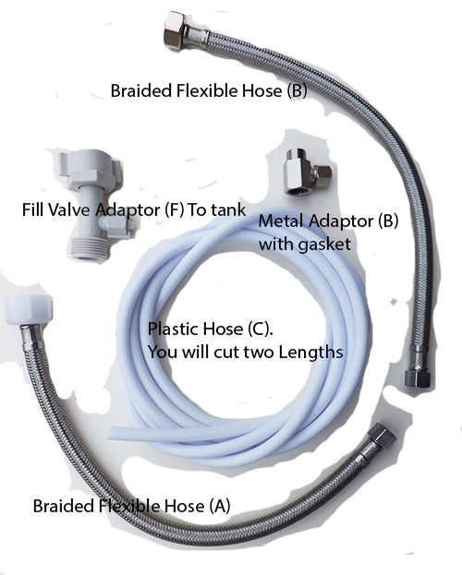

Preparation

- Shut-off water supply to the toilet tank by closing the valve that supplies the tank
2- Flush the toilet 2 times to make sure the water in the tank is fully drained
3- Shut-off the valve bringing hot water to your bathroom sink. This is under the sink. Turn the hot water faucet on to drain any water in pipe
4- Unscrew bolts in back of toilet seat to remove the seat from toilet. Put away for now.
Toilet seats are normally connected with two long screw bolts and wing nuts (on bottom side), one on each side

Final Assembly Image

Follow step by step. This image above gives you what the final picture should look like

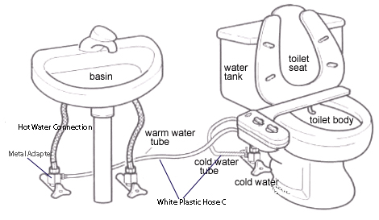

- Cold Water Connection:
1- Disconnect the braided flexible hose below the toilet water tank. Disconnect only the tank end. (make sure you had flushed the tank as indicated above. Wrap a small piece of Teflon around the threads on male end at the tank end

2- Connect Fill Valve Adaptor (F) to the top of the hose from step 1(the end you disconnected from the tank). Screw the Fill Adaptor to the male end at the tank bottom. Tighten. Try to orient the nipple on the Fill Adaptor towards you to make it accessible
3- Unscrew the plastic wing nut in middle of Fill Valve Adaptor (F) to expose connection nipple. Wrap a small piece of Teflon on the threaded part of the nipple
4- Slide the plastic wing nut -from step (3) onto one end of the narrow gauge White Plastic Hose (C). Connect hose end to the exposed nipple on Adaptor (F). Make sure you push hose on all the way up to where threading begins. Support the back of the Fill Adaptor with your palm while you are pushing the hose over nipple. Then, screw the plastic wing nut back onto the nipple of Fill Valve (F). Tighten connection by hand.
5- Put the Waterkleen™ Bidet on the porcelain toilet without bolting it. Then estimate the length of the White Plastic Hose (C) you need to make a connection between the Fill Adaptor and the nipple market cold water on the bidet. Leave some slack. Using scissors cut the Plastic Hose at the estimated length. Make sure you make a straight cut / not at an angle

Do not yet connect the hose to the nipple on the bidet. Do not yet connect the bidet to the toilet.
Congratulations you just completed the cold water connection.
If you are planning to only connect bidet to cold water, you can jump to Step V below.

- Hot Water Connection
For this connection, you will be using Metal Adaptor (B). Please note, Adaptor (B) is made to screw on a standard 5/8” hot water Shut-Off valve (coming out of the wall) Depending on the age of your plumbing, your hot water valve may be of a different size (1/2” or possible 7/8”). If this is the case, you will need coupling to connect Metal Adaptor (B) to the Shut-Off valve under the sink. One end of the coupling should be 5/8” to connect to the Metal Adaptor (B). The other end should be what fits the size of your Hot Water Valve. You can buy the coupling from Home Depot and most hardware stores for about $3. Buy one made out of metal. If you need to get the coupling, make sure you also get rubber gaskets to fit into the female ends, you will need this to prevent leaks and always use Teflon tape on threads

- With your hot water Shut-Off valve under the bathroom sink closed

- Unscrew and remove the flexible hose that extends from the Shut- Off valve to the bottom of your to the faucet connection

- Look into the fat end of the metal Adaptor (B) and make sure that the gasket that comes with it is secure inside – it may have come loose in your pack during shipping

- Screw the metal Adaptor (B) onto the hot water Shut-Off valve and then screw the Braided Flexible hose (B) on the Adaptor's threaded end. Make sure you use a couple of wraps of Teflon tape around the threads to prevent leaks.

- Tighten the other connection to the hot water faucet below the sink. Make sure that connections are tight - do not over tighten! Make sure the nipple on the Metal Adaptor is accessible to you on front or on the side.

- Now, screw off the small metal nut from the Metal Adaptor (B) to expose the connection nipple. Wrap a small piece of Teflon on threaded part of nipple

- Slide the metal nut onto one end of the remaining piece of the narrow gauge White Plastic Hose (C). Connect the hose to the nipple onto the Adaptor (B). Make sure you slide the hose all the way up to where threading begins. Tighten by hand.

Congratulations you now have connected hot water to your bidet
- Finishing Up

- Turn the bidet over and attach the free end of the narrow gauge White Hose C (from step III-5) to the exposed nipple on the bottom of the bidet marked Cold (Blue Color). Put Teflon tape on the threaded part of the nipple. Tighten the nut by hand.
Do not over tighten. If there’s a little water drop leaking down the hose, backout the nut a couple of turns
2. Attach the free end of the narrow gauge White plastic from the hot water connection Hose (C) – from step IV-7 to the exposed nipple on the bottom of the bidet marked Hot (Red Color). Remember to put Teflon tape on the theads. Do not over tighten.
3. Put the bidet facing up on the porcelain toilet
4. Line up the bidet slots with the wholes of the toilet. Lining the bidet up to the last adjustable slots on the right (as you face it) works best
5. Replace the toilet seat on top of the bidet and insert the bolts and the wing nuts to tighten
HOT WATER CAUTION
- Adjust the mix of hot water slowly. Once you have reached a temperature that is pleasing, leave the setting there.

- Never flush the toilet just before you turn on bidet or while you are using it. This may cause a sudden rise of temperature in the water coming out of the bidet nozzles. If this happens, immediately turn off the bidet flow from the flow nozzle until the toilet tank fills up, then you can safely turn on the bidet again. In all cases, if the water flowing out of the bidet is too hot for your skin, immediately turn off the flow valve.

LIMITED WARRANTY

Waterkleen™ offers double the normal warranty (2-years) of the industry because we are sure of the quality of our product. Should your bidet fain during the warranty period due to manufacturing defects, we will replace it free. Simply call our Customer service at 727-490-8633 or write to us at warranty@kleembottom.com. You are only responsible for the shipping costs.

RETURNS

DO NOT RETURN THE BIDET TO THE RETAIL MERCHANT
Kleenbottom.com accepts returns on new and unused products within 30 days of shipment date. New and unused means the bidet has not been installed, used or altered in any way and remains in re-saleable condition. Due to the hygiene nature of our business, any products that have been hooked up to water or used in any way are not eligible for return due to Public Health Regulations and Kleenbottom.com policy.
Returns must still be in their original packaging with all parts and accessories included or shall be subject to a 15% restocking fee.
RMA (Return Merchandise Authorization)
Customers must first contact Kleenbottom.com and obtain an RMA number. Send us an email at returns@Kleenbottom.com with your order number and we’ll gladly issue an RMA for qualified returns.
Returns without an RMA number will not be accepted.

.

THANK YOU FOR BUYING THE WATERKLEEN BIDET
discount
Consider adding another to your household or refer us a friend. Discount Code Express15 to get 15% discount on the order

